Explanation of Data Files

With

No Down-Regulation Effect of Affect Labeling on Negative Emotions Across Different (Re)Exposure Time Points
Authors: Jinyu Chen, Johanna M.P. Baas, J.Leon Kenemans, Irene van de Vijver,
Author affiliation: Experimental Psychology and Helmholtz Institute, Utrecht University

Contents
Experiment 1 and Baseline Correction 2
Materials 2
Task Design 2
Immediate Exposure Phase 2
Short- and Long-Interval Reexposure Phases 2
DATA 3
Experiment 2 and Baseline Correction 5
Materials 5
Task Design 5
DATA 5

Experiment 1 and Baseline Correction

Materials
The selected pictures (N = 320; negative and neutral) were divided into eight subsets (Image-set: affect_labeling, affect_matching, new_shorter_interval, new_long_interval). Immediate exposure included the affect-labeling and affect-matching sets. The short-interval and long-interval re-exposure phases additionally included their corresponding new sets.
•The folder titled “Open_Data_Affect_Labeling_Self-reports” contains an Excel file named “image_selected_exp1_exp2,” which provides comprehensive information about the images used in the experiment 1 (sheet, exp1). The file includes each image’s filename, transformed normative ratings (1–9 Likert scale) for arousal and valence, and Picture Valence (negative, neutral). Additionally, the file indicates how each image was pseudorandomly assigned to a specific Image-set (affect_labeling, affect_matching, new_shorter_interval, new_long_interval). The Image-set corresponds to the Intervention Condition (affect labeling, affect matching, new_shorter_interval, new_long_interval). In the present study, only the affect labeling and affect matching conditions were included.

Task Design
The affect labeling paradigm consisted of three phases: immediate exposure, short-interval reexposure, and long-interval reexposure. The immediate phase consisted of the label-or-match intervention and the emotion rating, whereas the short-interval and long-interval phases involved only the emotion rating.
Each phase comprised five blocks in total. The immediate and short-interval phases were conducted in a combined session. The first two blocks began with the label-or-match task, followed by the emotion rating as part of the immediate exposure phase. The third block began the short-interval reexposure phase with the emotion rating alone. Subsequently, blocks alternated between immediate and short-interval phases until all five were completed.

Immediate Exposure Phase
Each trial of the label-and-match intervention in the immediate exposure phase (Figure 1, panel A) began with a fixation of 2000 ms, followed by a 3000 ms presentation of a target picture, during which participants observed the target picture and experienced any emotions it elicited. Subsequently, word pairs (affect labeling) or image pairs (affect matching) appeared below the target picture for selection, with no time limit for response. The appearance of words or image pairs signaled the task type for each trial. Participants selected the option with the mouse that best reflected their emotional feelings by pressing "left" for the left choice or "right" for the right choice. Subsequently, the previously labeled or matched target was reexposed in the emotion rating, and participants rated their feelings using the arousal and valence scales.
This task consisted of four conditions with 160 trials, each presenting a picture from each of the four subsets for label negative, label neutral, match negative, and match neutral. These trials were mixed and then pseudorandomly divided into five blocks, with the block order randomly assigned for each participant. Each trial of affect labeling and affect matching for positive stimuli was included in each block, resulting in 170 trials.

Short- and Long-Interval Reexposure Phases
Each trial of the emotion rating during short- and long-interval phases (Figure 1, panel B) began with a 1000 ms fixation period, followed by a 3000 ms presentation of the emotional target picture. The arousal and valence rating scales were displayed until the participant responded.
This task consisted of six conditions with a total of 240 trials. Each of the pictures from the immediate exposure phase, plus the two subsets of new pictures, was presented. The block in which pictures appeared in the short-interval and long-interval reexposure phase was contingent on the timing of their appearance in the immediate exposure phase.

DATA
- The folder ‘Open_Data_Affect_Labeling_Self-reports’ contains an Excel file named ‘Exp1_arousal_3phases_ratings_diff’, and ‘Exp1_valence_3phases_ratings_diff’, which includes raw data on arousal and valence ratings collected for each trial per participant, along with their response times during the rating task, respectively.

- The same columns in both files are: Subject, Image, Intervention_Condition, Pic_Valence, Emotion, Group, Phase
- Within-subject factors
  - Intervention_Condition (labeled, matched)
  - Picture_Valence (negative, neutral)
  - Phase (immediate, short-interval, long-interval)
- Between-subject factor: Group (high ADS, low ADS)

Arousal Rating
- Arousal_Tnorm: normative arousal rating of each image obtained from the Dutch norm data, with a 1-9 scale.
- Dependent variables
  - Arousal_post: participants’ arousal ratings collected during the three reexposure phases following the intervention
  - ArousalRT_post: Response time (in ms) required to provide the arousal rating during the reexposure phases
  - diff_arousal: difference score calculated (Arousal_post − Arousal_Tnorm), which reflects the deviation of participants’ post-intervention ratings from the normative image rating (used for baseline correction)

Valence Rating
- Valence_norm: normative valence rating of each image obtained from the Dutch norm data, with a 1-9 scale.
- Dependent variables
  - Valence_post: participants’ valence ratings collected during the three reexposure phases following the intervention
  - ValenceRT_post: Response time (in ms) required to provide the valence rating during the reexposure phases
  - diff_valence: difference score calculated (Valence_post − Valence_Tnorm), which reflects the deviation of participants’ post-intervention ratings from the normative image rating (used for baseline correction)

Figure 1
Experiment 1: (A) Illustration of the sequence of events in a trial of the label-or-match task, followed by the emotion rating using the arousal and valence scales during the immediate exposure phase, and (B) the sequence of events in a trial of the emotion rating task using the arousal and valence scales in the short- and long-interval re-exposure phases.
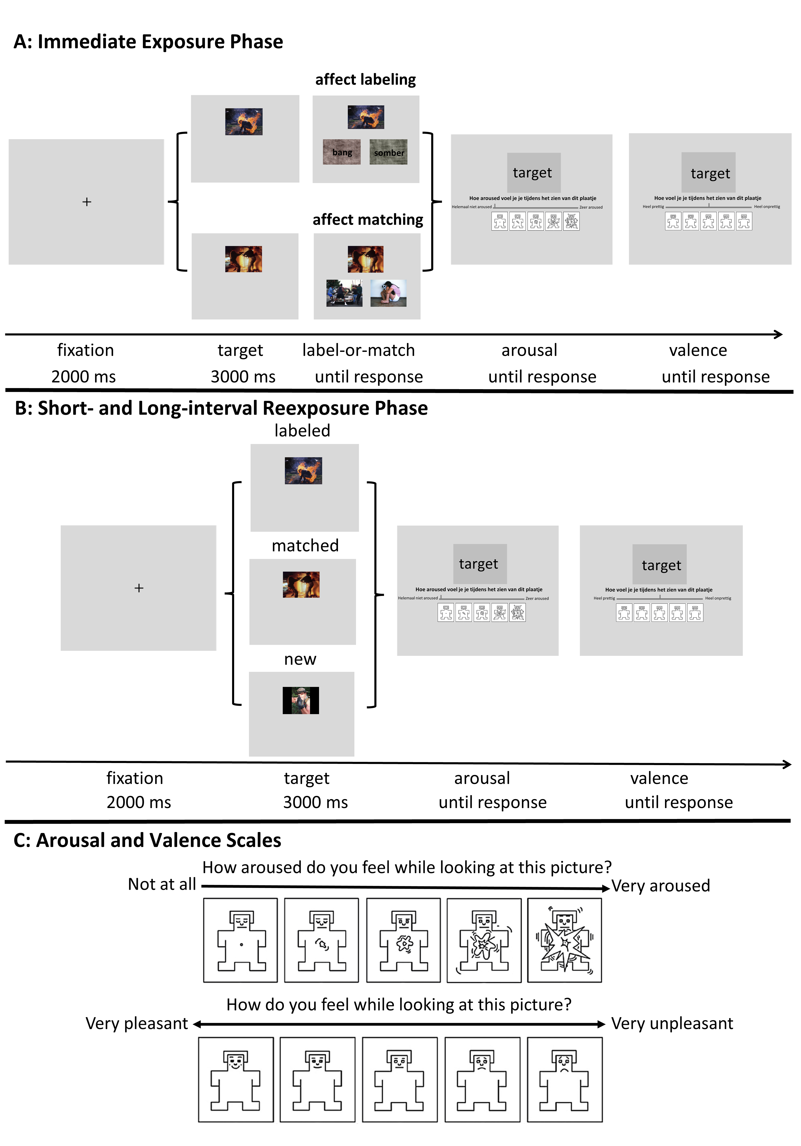
Note. The arousal scale (panel C, top) uses a slider starting from the left, where moving the slider further to the right indicates higher arousal. The valence scale (panel C, bottom) uses a slides that starts in the middle, with movement further to the left indicating a more pleasant rating, and movement further to the right indicating a more unpleasant or less pleasant rating.

Experiment 2 and Baseline Correction

Materials
The primary modification in Experiment 2 was the random assignment of images to intervention conditions. In addition, a feature labeling condition was introduced in the label-or-match task prior to the immediate reexposure phase. As a result, a total of 240 images were required: 40 negative and 40 neutral images for each of the three intervention conditions (affect labeling, affect matching, and feature labeling). Of these, 232 images were drawn from the stimulus set used in Experiment 1, and 8 additional images were newly included.
•The folder titled “Open_Data_Affect_Labeling_Self-reports” contains an Excel file named “image_selected_exp1_exp2,” which provides comprehensive information about the images used in the experiment 2 (sheet, exp2). The file includes each image’s filename, transformed normative ratings (1–9 Likert scale) for arousal and valence, and Picture Valence (negative, neutral). All images are randomly assigned to the Intervention Condition(affect labeling, affect matching, feature labeling).

Task Design
To adapt the task design to the EEG measurements, each trial began with a jittered fixation (1500-2000 ms), followed by the label-or-match task and a fixed intertrial interval (ITI; 1000 ms). The target image was then immediately represented (immediate exposure), followed by a second ITI and a subsequent rating (Figure 4). The same jitter fixation and ITI were used before and after picture presentation during the short-interval re-exposure phase. Additionally, during the label-or-match task, the feature labeling was added (see Figure 2).

DATA
- The folder ‘Open_Data_Affect_Labeling_Self-reports’ contains an Excel file named ‘Exp2_arousal_3phases_ratings_diff’, and ‘Exp2_valence_3phases_ratings_diff’, which includes raw data on arousal and valence ratings collected for each trial per participant, along with their response times during the rating task, respectively.

- The column structure is the same as in the Experiment 1 data files, with two exceptions:
  - There is no Group factor in Experiment 2
  - The Intervention Condition factor includes an additional level: feature labeling (in addition to affect labeling and affect matching).

Figure 2
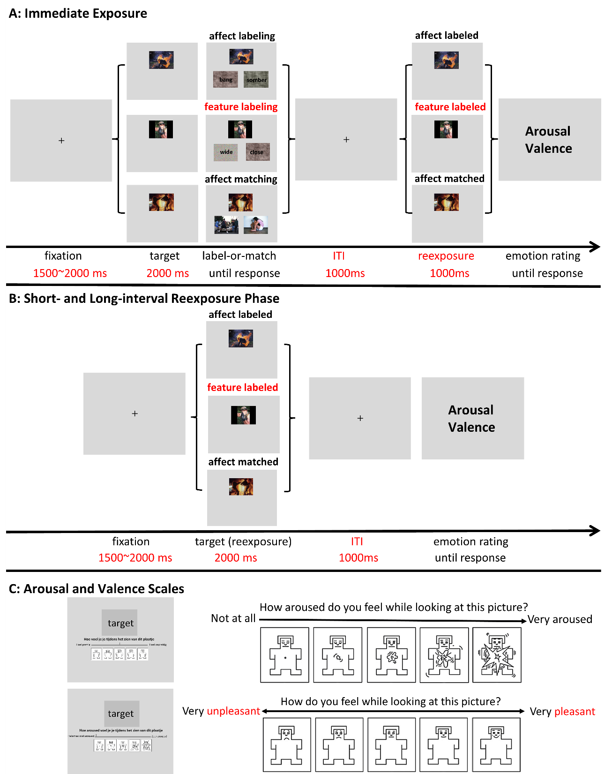
Experiment 2: A) Illustration of the sequence of events in a trial of the label-or-match task, followed by the emotion rating using the arousal and valence scales during the immediate exposure phase and (B) the sequence of events in a trial of the emotion rating task using the arousal and valence scales in the short- and long-interval re-exposure phases.
Note. The red words indicate modifications compared to experiment 1. Time schedules for arousal and valence ratings were identical to those in Experiment 1.

